**Project Description:** **Leave Application and Approval System Test**

**Working Of The Project**

First we uses the username and password for login after the login validation if the login success there is returning a token. The token for authentication purpose. When one user Is login to system or application the token are helpful to check who is consuming the application. After login success the employee can see the available leave and he/she can apply the leave to their wanted date. After the submission of leave the manager can the authorised to approve or reject that applied leave. If the employee request for leave is approved the employee can take the leave. If the mananger reject the leave the employee can’t take the leave on that day.

start

Requesting Leave

Evaluating Leave Application

Rejected Approved

Checking leave status

Checking the status

Take leave

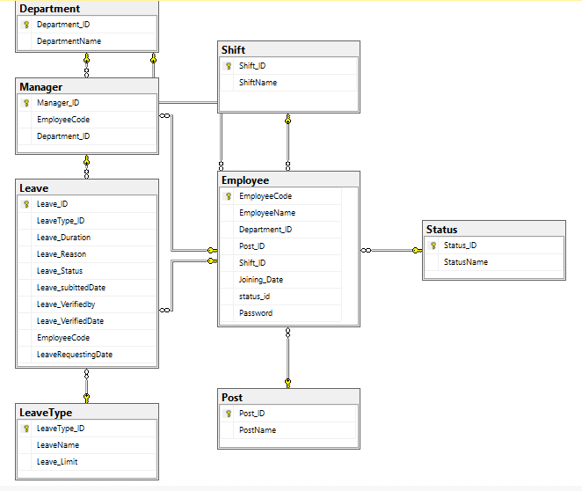

**Used Database**

CREATE DATABASE LeaveApplicationSystem;

**Used Tables**

CREATE TABLE Department (

Department_ID int IDENTITY(1, 1) NOT NULL PRIMARY KEY,

DepartmentName varchar(25)

);

CREATE TABLE Shift (

Shift_ID int IDENTITY(1, 1) NOT NULL PRIMARY KEY,

ShiftName varchar(25)

);

CREATE TABLE Post (

Post_ID int IDENTITY(1, 1) NOT NULL PRIMARY KEY,

PostName varchar(25)

);

CREATE TABLE Status (

Status_ID int IDENTITY(1, 1) NOT NULL PRIMARY KEY,

StatusName varchar(25)

);

CREATE TABLE LeaveType (

LeaveType_ID int IDENTITY(1, 1) NOT NULL PRIMARY KEY,

LeaveName varchar(25),

);

CREATE TABLE Leave (

Leave_ID int IDENTITY(1, 1) NOT NULL PRIMARY KEY,

LeaveType_ID int FOREIGN KEY REFERENCES LeaveType(LeaveType_ID),

Leave_Duration int,

Leave_Reason Varchar(50),

Leave_Status int,

Leave_subittedDate date,

Leave_Verifiedby int FOREIGN KEY REFERENCES Manager(Manager_ID),

Leave_VerifiedDate date

);

CREATE TABLE Employee (

EmployeeCode int IDENTITY(1, 1) PRIMARY KEY,

EmployeeName varchar(25),

Department_ID int,

Post_ID int,

Shift_ID int,

Joining_Date date,

Status_ID int,

FOREIGN KEY (Department_ID) REFERENCES Department(Department_ID),

FOREIGN KEY (Post_ID) REFERENCES Post(Post_ID),

FOREIGN KEY (Status_ID) REFERENCES Status(Status_ID),

FOREIGN KEY (Shift_ID) REFERENCES Shift(Shift_ID)

);

CREATE TABLE Manager (

Manager_ID int IDENTITY(1, 1) NOT NULL PRIMARY KEY,

EmployeeCode int FOREIGN KEY REFERENCES Employee(EmployeeCode),

Department_ID int FOREIGN KEY REFERENCES Department(Department_ID)

);

**Used Procedure**

USE [LeaveApplicationSystem]

GO

/****** Object: StoredProcedure [dbo].[EmployeeLeaveDetails] Script Date: 09-06-2024 18:11:01 ******/

SET ANSI_NULLS ON

GO

SET QUOTED_IDENTIFIER ON

GO

-- =============================================

-- Author: Lima K M

-- Create date: <Create Date,,>

-- Description: <Description,,>

-- =============================================

ALTER PROCEDURE [dbo].[EmployeeLeaveDetails]

@EmployeeName varchar(25)

AS

BEGIN

SELECT

lt.LeaveType_ID,

lt.LeaveName,

lt.Leave_Limit - COALESCE(COUNT(l.Leave_ID), 0) AS AvailableLeave,

COUNT(l.Leave_ID) AS LeaveTakenCount

FROM

LeaveType lt

LEFT JOIN

Leave l ON lt.LeaveType_ID = l.LeaveType_ID AND l.EmployeeCode = (SELECT e.EmployeeCode FROM Employee e WHERE e.EmployeeName = @EmployeeName)

GROUP BY

lt.LeaveType_ID,

lt.LeaveName,

lt.Leave_Limit;

END

**Test The Project**

For testing purpose using the POSTMAN. For example . The PostMan is mostly used for testing APIs. In this I am testing the leave type list of provided leave to employee.

